Chemistry 141 Name Key
Dr. Cary Willard
Quiz 7A (20 points) March 19, 2009

- (4 points) The heat of formation of liquid ethanol CH₃CH₂OH is -277.69 kJ. Write the reaction described by this heat of formation.

3 H₂(g) + 2 C(s) + ½ O₂(g) CH₃CH₂OH(l)

- (10 points) In photosynthesis, the sun’s energy brings about the combination of CO₂ and H₂O to form O₂ and a carbon-containing compounds such as a sugar. In its simplest form the reaction could be written

6 CO₂(g) + 6 H₂O(l) 6 O₂(g) + C₆H₁₂O₆(s)

ΔH = 6 ΔH_{f} O₂,g + ΔH_{f} C₆H₁₂O₆, s – 6 ΔH_{f} CO₂, g – 6 ΔH_{f} H₂O, l

ΔΗ = 6( 0 kJ) + (– 1274.4 kJ) – 6(–393.5 kJ) – 6(–285.8 kJ)
= 0 kJ + (– 1274.4 kJ) + 2361.0 kJ + 1714.8 kJ

= + 2801.4 kJ

What is the energy change for the formation of 100.0 g of sugar?

$$?energy required=100.0 g C_{6}H_{12}O_{6}×\frac{1 molC_{6}H_{12}O_{6}}{180.16 gC_{6}H_{12}O_{6} }×\frac{2801.4}{1 molC_{6}H_{12}O_{6}}=\boxed{1555 kJ}$$

- (6 points) Estimate the ΔH for the conversion of 2 mol of ammonia from molecular nitrogen and molecular hydrogen. Is this reaction endothermic or exothermic?

3 H₂ + N₂ 2 NH₃

Bonds broken |  | Bonds formed
3 H−H | 3(436 kJ) | 6 N−H | 6(−390 kJ)
1 N≡N | 945 kJ
total | 2253 |  | −-2340

The energy of the reaction is −87 kJ/reaction. This is an exothermic reaction

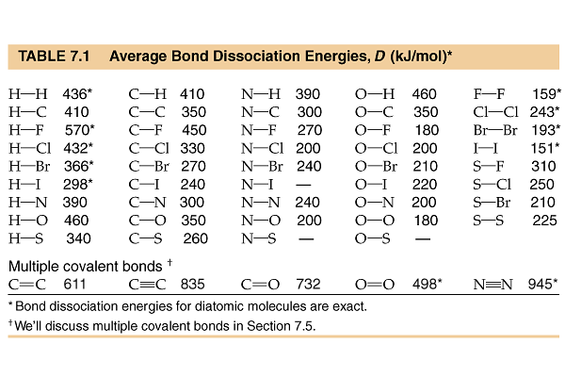

Heats of formation

compound | ΔHº_{f} (kJ/mol)
CO₂(g) | -393.5
H₂O(l) | -285.8
H₂O(g) | -241.8
C₆H₁₂O₆(s) | -1274.4

